Vladyslava Bucharska, Mariia Kibets, Pavel Tsydzik

Software Requirements & Implementation Specification
Hotel „bounty” managment System
[Document subtitle]

Contents
Contents 2
User requirements 4
Use case Diagram 6
Class Diagram - Analytical 7
Analytical Class diagram – Description 8
Class Diagram – Design 10
Design decision 11
Attribute Validations 11
Optional Attribute 12
Multy-Value Attribute 12
Derived Attributes 12
Persistence implementation 14
General association implementation 14
Composition 15
Qualified association 15
Association class 16
Reflex association 17
Association validation 17
Inheritance Solution chosen 19
Use case scenario: “Register” 21
Activity Diagram “Register” 22
Activity Diagram Description “Register” 23
Use case scenario “Pay for booking” 24
Activity Diagram “Pay for booking” 24
Activity Diagram Description “Pay for Booking” 25
Use case scenario “Make Booking” 26
Activity Diagram “Make Booking” 27
Activity Diagram Description “Make Booking” 28
State Diagram Booking Class 29
State Diagram Description 30
Dynamic analysis on „Make a Booking”, „Prepay booking”, „Pay for booking” and “Cancel booking”use cases and “Booking class” state diagram 31
Changes to the Class diagram after dynamic analysis 34

User requirements
To book a room, firstly, the user should register as a guest in the system. So, after clicking on REGISTER button, the guest should enter the personal info: name, address, pesel number. In the next tab, there will be the option to choose the date of birth, and the system will calculate the age of the person. After submitting the correct personal info and the person’s age is more than 18, the user will receive the unique guest card number, by which the guest can login into the system and book the room.

After registering and logging in via guest card, the guest can book the available room and view the list of bookings. After it, the booking tab will appear, where the guest should enter the valid check-in and check-out dates. After browsing some rooms and finding the desired one, the guest clicks on the BOOK button. The guest can choose the preferred room type, as well as additional features that he would like to see during his stay. From the available options the user can select the room type Standard or Deluxe and also select Pet Friendly or No Pets type. After the guest has selected all the necessary options and booked a vacation at our hotel, he must pay a deposit of $100. After payment, the system will display a window confirming the successful booking. Also, the guest an check the list of the bookings and check the state of concrete booking and cancel the booking if the guest wants to.

To make a full payment, the user has to follow these steps. For the first step, the guest needs to choose the payment method. Then guest enters the payment details. Also the guest can have the ability to add a discount code or a coupon. Then the guest chooses the date of the operation and pays. After the successful operation, the bill will be generated by the system.

In our system when guest make a booking, class Booking can turn into different states. The first state is – preparing, in which guests input and choose information that is required. In case of not continuing the operation class, booking automatically turns into a cancelled state. When the guest wants to continue the operation, the Booking class turns into prepayment awaiting state. If the guest wants to cancel the operation, the state will be cancelled. Once in the “Canceled” state, if no further actions occur, the booking is automatically removed from the system after one hour. After successful prepayment, the state of the booking will change to booked. The guest can make the whole payment at any time before the arriving; the state of the class will be changed to paid. When the valid term of the booking expires, the receptionist marks it as completed. At any time the user can check the state of the booking in the system.

In deluxe rooms the cleaning is provided daily, but in standard rooms only on request. To have a cleaning room, the guest should book it. Also, the system can generate on request the list of available rooms and the list of rooms to clean. Each employee can extract the list of available rooms, and cleaner can additionally get the list of rooms to clean. Also the employee can check the current salary. The receptionist can view the list of all employees and, if needed, edit the information about them. As well as view the list of all guests and edit information about the guests.

Use case Diagram

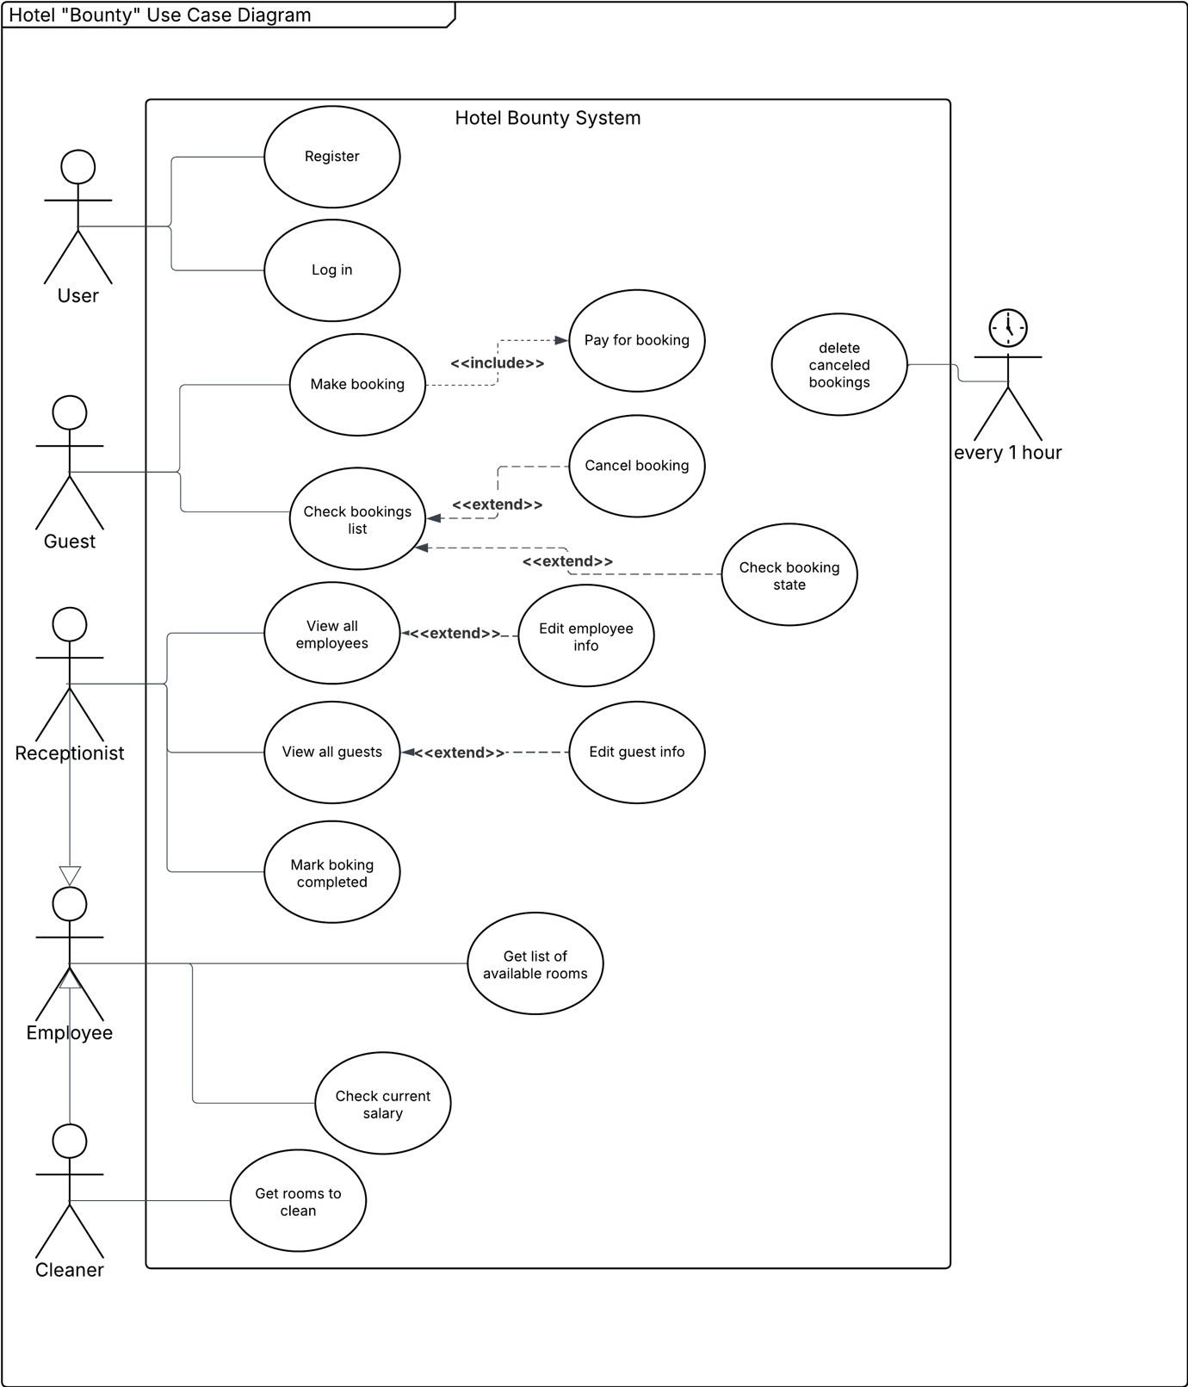

Class Diagram - Analytical
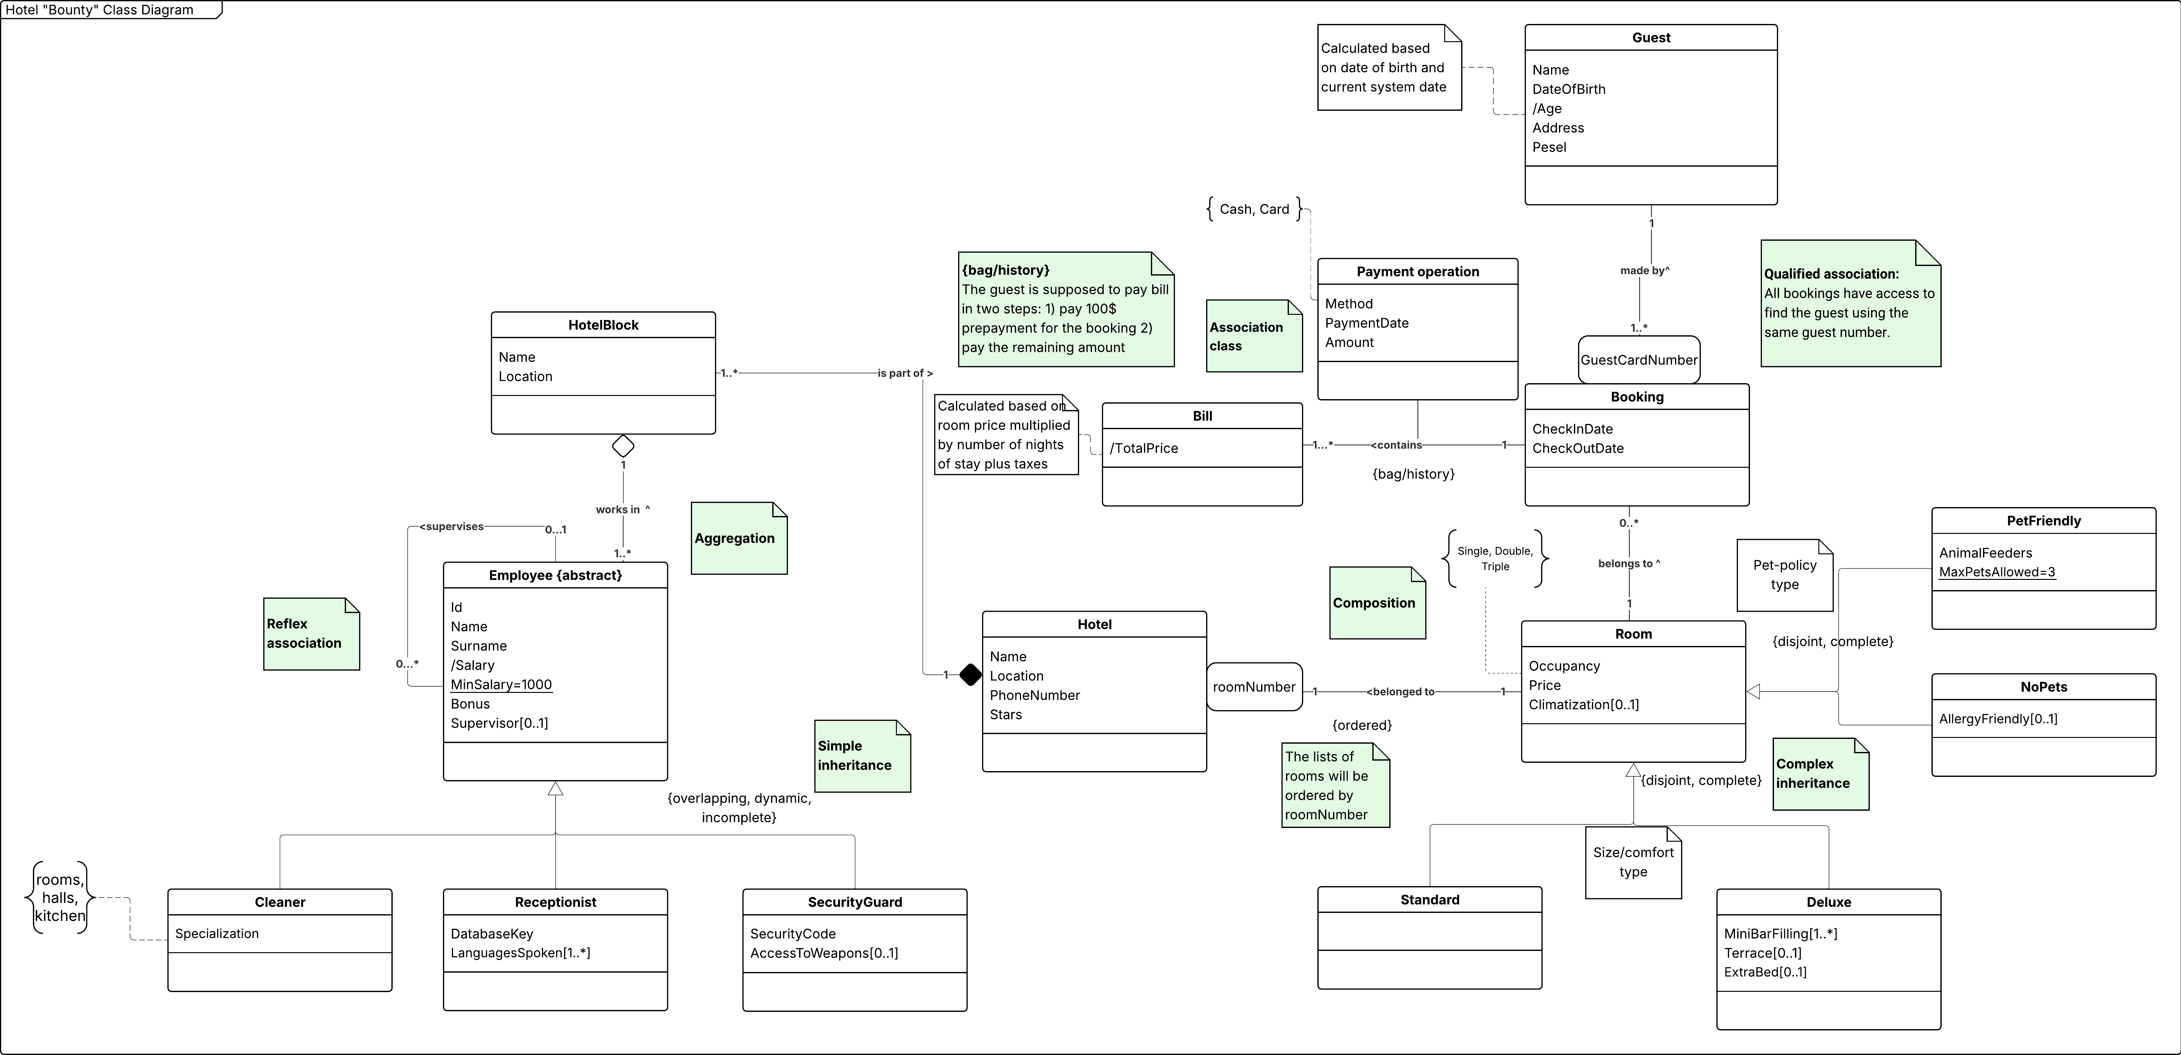

Analytical Class diagram – Description

Hotel “Bounty” needs a system to manage all the hotel work and improve productivity. The system gives the opportunity to guests to book a great vacation at our hotel as well as employees can organize their work easily.

Firstly, we want to store in the system description of the hotel, including: name, location, phone number, rating and stars. The hotel also contains rooms which are identified and ordered in the system by its number. {ordered}

Our system manages booking effectively, storing Check-In Date and Check-Out Date. For booking operations we store information about our guests that are identified by their Guest Card Number. The information consists of name, date of birth, address and calculated age based on date of birth and current system date. Per one booking, guests can book only one room.

There is the possibility to generate a bill which calculates the total based on the price of the room price multiplied by number of nights of stay plus taxes. If the bill was lost, there is the possibility of generating a bill again. Also, the system provides tracking information about payment operations. Payment Operation includes method of payment (cash or card), payment date and amount. In our system payment is held in two steps. The first one requires 100$ prepayment, the second one is the remaining amount. {bag/history}

The room information includes its price, occupancy (single, double, triple) and climatization availability. Guests are able to choose a room by its size/comfort type and pet policy. In case of comfort grading there are two options: Standard and Deluxe. The Deluxe room can optionally have a terrace and an extra bed. Additionally, in the deluxe room the list of minibar filling is provided. For each room type we can choose the pet policy type: Pet Friendly and No pets. Pet Friendly contains information about available Animal Feeders. The maximum allowed number of pets in the room is 3. No Pets room provides a choice to have an allergy friendly room.

The hotel consists of several parts that are named blocks. Each block has its name and location. Each employee is assigned to the concrete block for working. If the block is closed for renovation for example, the employee has the opportunity to start working in another block.

Our system contains information about our employees: id, name, surname, salary, minimum salary of 1000$ and their bonuses. The employee can supervise colleagues. We have 3 types of employees available now: cleaner, receptionist, security guard. Each employee can work on multiple jobs at the same time or change the job over time. The cleaners are qualified by their specialization: rooms, halls, kitchen. Every receptionist has a unique database key, and the system records which languages they speak. Every security guard has their own security code and optionally they can have access to weapons. More jobs will be introduced later.

Class Diagram – Design
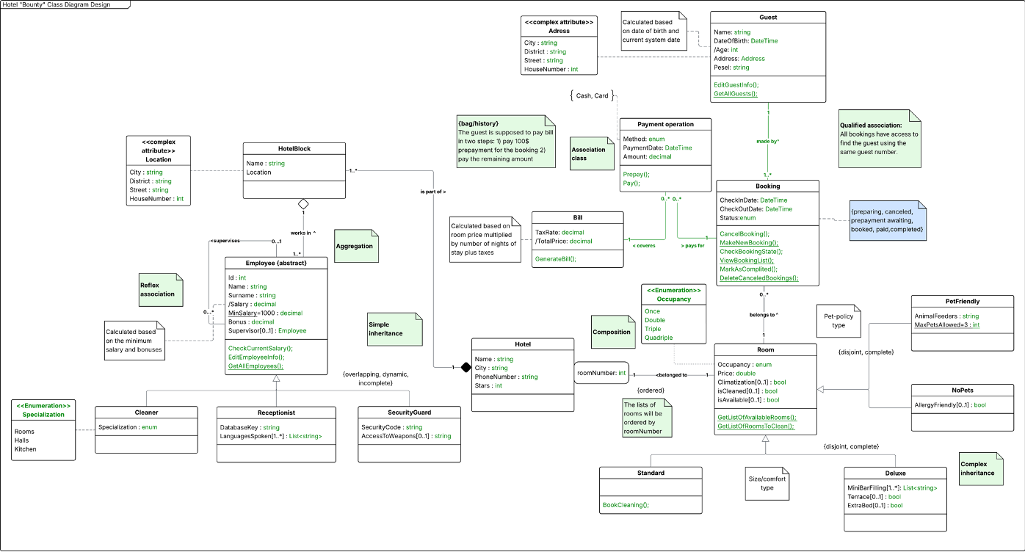

Design decision
The class diagram above shows the changes needed to represent UML features that are not directly supported in C#. The final implementation will use Entity Framework Core for data persistence, and the design decisions related to this are discussed in the next section. The newly introduced changes are highlighted in green.
The following section explains how specific UML constructs—such as attribute types based on UML notation—are transformed during the implementation process.

Attribute Validations
In this project, attribute-level validation was implemented manually through custom C# logic. This approach ensured precise control over validation rules for the classes. Example of usage in this project:
- Numeric validation, such as preventing negative values for attributes like room price, maximum number of pets, or employee salary.
- String validation, ensuring non-null, non-empty, and non-whitespace values for fields such as names, feeder descriptions, mini-bar items, or personal identifiers.
- Association validation, preventing null references for mandatory relationships (e.g., every Room must be associated with a non-null Hotel, every HotelBlock must have a valid Address, etc.).
- Range validation, such as restricting the number of pets allowed in a PetFriendly room to within an acceptable predefined range.
- Structural validation, including ensuring that collections (e.g., mini-bar items in Deluxe rooms) contain valid, non-null items.
Each validation rule in the project was written directly in the property setters and constructors using simple checks (guard clauses). When something is wrong—like a negative price, an empty string, or a missing required object—the code immediately throws an appropriate exception (such as ArgumentException or ArgumentNullException). This makes the system more reliable and keeps the data correct. It also ensures that the rules used in the code match the real requirements shown in the project’s domain diagram.

Optional Attribute
In this project, optional attributes are the ones that do not require a value and can be left empty. These attributes are implemented in C# using nullable strings (string?). A nullable string allows the value to be null when the information is not provided.
In the class diagram, optional attributes are shown with the multiplicity [0..1], meaning the value may exist but is not required. This matches the implementation in the code, where certain string properties are optional and can remain unset. This keeps the model flexible while still following the rules from the project’s domain design.

Multy-Value Attribute
Multi-value attributes are attributes that can hold more than one value for a single object. These attributes are implemented in C# as collections, typically List<string>. This allows an object to store multiple values while still keeping them organized and accessible. For example Languge attribute is a multi-value attribute that ensures storing at least one language and prevents the storing of nullable value. As well as MiniBarFilling in the Deluxe room, which is a list of strings representing all items currently available in the minibar. Multi-value attributes help model real-world data more accurately, where a single property may naturally have multiple entries. For example, a minibar can contain several drinks, and a guest or employee can speak multiple languages.

Derived Attributes
Derived attributes are attributes whose values are calculated automatically from other attributes, rather than being stored directly. In C#, these are usually implemented with getters that include logic to compute the value whenever it is accessed.
In this project the examples are showed below:
- Guest.Age
public int Age => CalculateAge(_dateOfBirth);
The Age property is calculated from the DateOfBirth.
It is always up-to-date and does not need to be stored separately.

public int Age
{
get
{
var today = DateTime.Today;
int age = today.Year - DateOfBirth.Year;
if (DateOfBirth.Date > today.AddYears(-age)) age--;
return age;
}
}

- Employee.Salary
public decimal Salary => MinSalary + Bonus;
The Salary property is calculated automatically based on the MinSalary and the Bonus.
This ensures that any changes to the bonus immediately update the salary.
public decimal Salary
{
get
{
return MinSalary + Bonus;
}
}

- Bill.TotalPrice (via GenerateBill() method)
The total price of a bill is calculated based on the room price, the number of nights, and a tax rate.
This ensures the TotalPrice always reflects the booking details, without needing manual updates.
public void GenerateBill()
{
var nights = (Booking.CheckOutDate - Booking.CheckInDate).Days;
if (nights <= 0) nights = 1;

var basePrice = (decimal)Booking.Room.Price * nights;
var tax = basePrice * 0.08m; // 8% tax

TotalPrice = basePrice + tax;

}

Persistence implementation
In this project, persistence was implemented using XML serialization in C#. All classes that need to be saved (like Guest, Employee, Hotel, Room, Booking, Bill, etc.) are marked as [Serializable] and, where necessary, use [XmlInclude] for derived classes.
The system provides methods to save and load the entire set of objects (extents) to and from XML files. Example of usage:
- Saving extents: The ExtentPersistence.Save(filename) method writes all current objects to an XML file.
- Loading extents: The ExtentPersistence.Load(filename) method reads the XML file and recreates the objects, restoring the extents.
This approach ensures that all data in the system, including relationships between objects, can be persisted and restored easily without manually saving each attribute.

General association implementation
Add method: The Add method creates an association between two objects. It first checks whether the provided object is null and whether the association already exists, preventing invalid or duplicate links. The object is then added to the internal collection. Finally, the reverse connection is established by calling the corresponding method on the associated object. An internal flag is used to prevent infinite recursive calls.
Remove method: The Remove method deletes an existing association. It validates the input, checks whether the association exists, and removes the object from the internal collection. After that, the reverse connection is removed so that both objects no longer reference each other. Internal calls are handled safely to avoid recursion.
Change/Modify methos: The Change/Modify method updates an association by first removing the old reference (including its reverse connection) and then creating a new one. This ensures that both sides of the association always remain synchronized and consistent.

Composition
In this project, composition is implemented between Hotel and HotelBlock. Where a HotelBlock cannot exist without a Hotel, and its lifecylce fully controlled by Hotel.
Implementation: A HotelBlock must be assigned to a Hotel at creation using AssignHotel(Hotel hotel). Once assigned, the hotel cannot be changed, which enforces strong ownership (Block cannot change its hotel in composition). The Hotel keeps a collection of its blocks and controls adding and removing them using AddHotelBlock and RemoveHotelBlock.
Remove Behavior: Removing a HotelBlock from a Hotel destroys the block, not just the reference. The RemoveHotelBlock method calls block.Delete(), which:
- Removes all employees from the block
- Removes the block from the extent
- Clears the reference to the hotel
When a Hotel is deleted using DeleteWholeHotel, all its blocks are automatically deleted, which is a key feature of composition.

Qualified association
In this project, a qualified association is implemented between Hotel and Room, where each room is identified within a hotel by a qualification key: RoomNumber.

Implementation: The Hotel class stores rooms in a dictionary (Dictionary<int, Room>), where the key is the room number. This allows direct access to a room using its qualification key, for example GetRoom(int roomNumber), instead of searching through a collection.
The AddRoom(Room room) and RemoveRoom(int roomNumber) methods explicitly use the room number as an extra parameter (key), which is the main difference from a basic association.

Handling Key Changes: The RoomNumber property in the Room class notifies the hotel when its value changes by calling Hotel.OnRoomNumberChanging(...).
The hotel then updates its dictionary keys to keep the association consistent and prevent duplicate room numbers.
This ensures that the qualification constraint (unique room numbers per hotel) is always preserved.

Association class
In this project, the association class is implemented using the PaymentOperation class, which represents ann association between Booking and Bill with additional attributes such as PaymentsMethod, Amouunt, PaymentDate.

Implementation: Instead of a simple association between Booking and Bill, an extra class (PaymentOperation) is introduced to store data that belongs to the relationship itself, not to either class individually. PaymentOperation holds references to both Booking and Bill, making it the central element that connects them. Both Booking and Bill maintain collections of PaymentOperation objects, allowing multiple payments to be associated with the same booking and bill.

Handling the Extra Class: The association is managed through bidirectional methods:
Booking.AddPaymentOperation(...) / RemovePaymentOperation(...)
Bill.AddPaymentOperation(...) / RemovePaymentOperation(...)
The PaymentOperation class provides SetBooking(...) and SetBill(...) methods to establish reverse connections. Internal call flags are used to prevent infinite recursion when synchronizing both sides of the association.

Constarins and Logic: Once a PaymentOperation is assigned to a Booking or Bill, it cannot be reassigned, enforcing business rules and data consistency.
Additional validation ensures that a payment operation cannot link a bill and booking that do not belong together.

Reflex association
In this project, a reflexive association is implemented in the Employee class to model a supervisor–relationship, where employees can be related to other employees of the same class.
Implementation: Both sides of the association are implemented within the same class (Employee), which is the key difference from a basic association. Each employee can have: One supervisor (Employee? _supervisor). Multiple supervisees (HashSet<Employee> _supervisees). This creates a one-to-many reflexive association.
Association management: The method SetSupervisor(Employee newSupervisor)
assigns a supervisor and automatically:
- Removes the employee from the previous supervisor’s supervisees.
- Adds the employee to the new supervisor’s supervisees.
The reverse relationship is always maintained inside the same class, ensuring consistency. AddSupervisee (Employee e) and RemoveSupervisee (Employee e) provide alternative ways to manage the same relationship from the opposite role.
Constraints and Validation:
- An employee cannot supervise themselves.
- Duplicate supervisor or supervisee assignments are prevented.
- Removing a supervisor or supervisee updates both sides of the reflexive relationship.

Association validation
In this project, association are carefully validated to ensure data consistency business rule enforcement, and safe bideirectional synchronization.

Null and duplicate validation: Before creation or removing any association, the code checkks for invalid inputs: ArgumentNullException is thrown when a required object is null. Duplicate associations are prevented using collection checks.
Example of implementation:
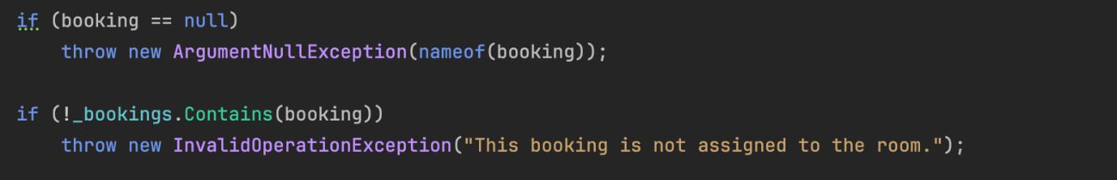

Reverse connection and recursion prevention: All bidirectional association use an internallCall flag to prevent infinitie recursive calls when synchronizing both sides of the relationship.
Example of the implementation:
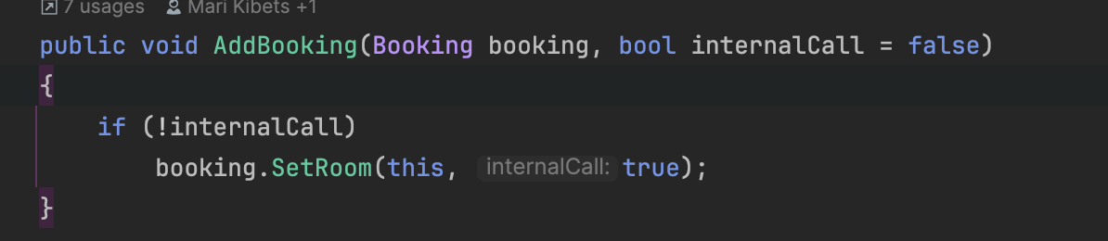

Existence and ownership checks: Associations validate whether an object already belongs to another parent, especially in composition and qualified associations.
Example of implementation:
A Room cannot be added to two hotels. A HotelBlock cannot change its hotel once assigned. A room number must be unique within a hotel.
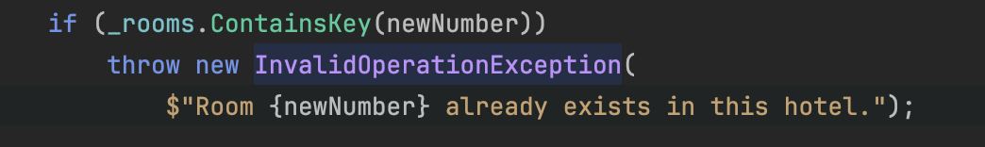
State-based validation: Some association that were implemented depend on object state: A completed or canceled booking cannot change its room and a bill or payment operation cannot be reassigned once set.
Example of implementation:
Reflexive association validation: For self-associations (Employee–Employee) self-references are forbidden. Duplicate supervisor/supervisee relationships are prevented. Removing one side updates the other.
Example of implementation:
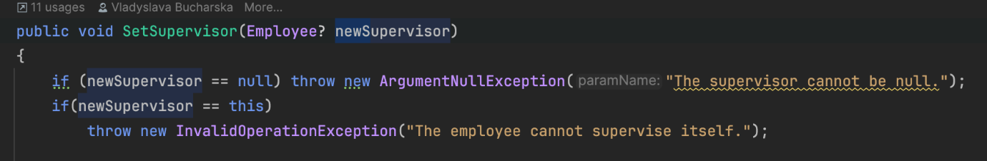

Inheritance Solution chosen
In this project, the flattening method was chosen to implement inheritance. This method was selected because it is simple, clear, and easy to maintain. Flattening combines all inherited attributes and behaviors directly into a single class, avoiding complex class hierarchies.

The Employee class uses the flattering method to handle overlapping and
dynamic inheritance. Instead of creating multiple parent classes, all required fields and behaviors are placed directly inside the Employee class. Overlapping features are managed by clearly defining shared attributes once, while dynamic behavior is handled using conditional logic within the class.
This approach makes the code easier to understand, reduces dependency between classes, and simplifies debugging. It also works well for this system because the roles and behaviors of employees can change at runtime.

The Room class utilizes the flattening method to implement disjoint inheritance. Instead of creating separate subclasses for distinct room types (such as Standard, Deluxe, or PetFriendly), all unique attributes like Terrace, PetFeeders, or AllergyFriendly are consolidated into the single Room class.
The distinction between room categories is managed through a RoomType discriminator property. Validation logic is centralized within the constructor to ensure that specific constraints (e.g. providing feeders for a pet-friendly room) are enforced based on the selected type. This approach simplifies data management by allowing all rooms to be stored in a single collection, making operations like filtering available rooms or managing bookings straightforward and efficient.

Use case scenario: “Register”
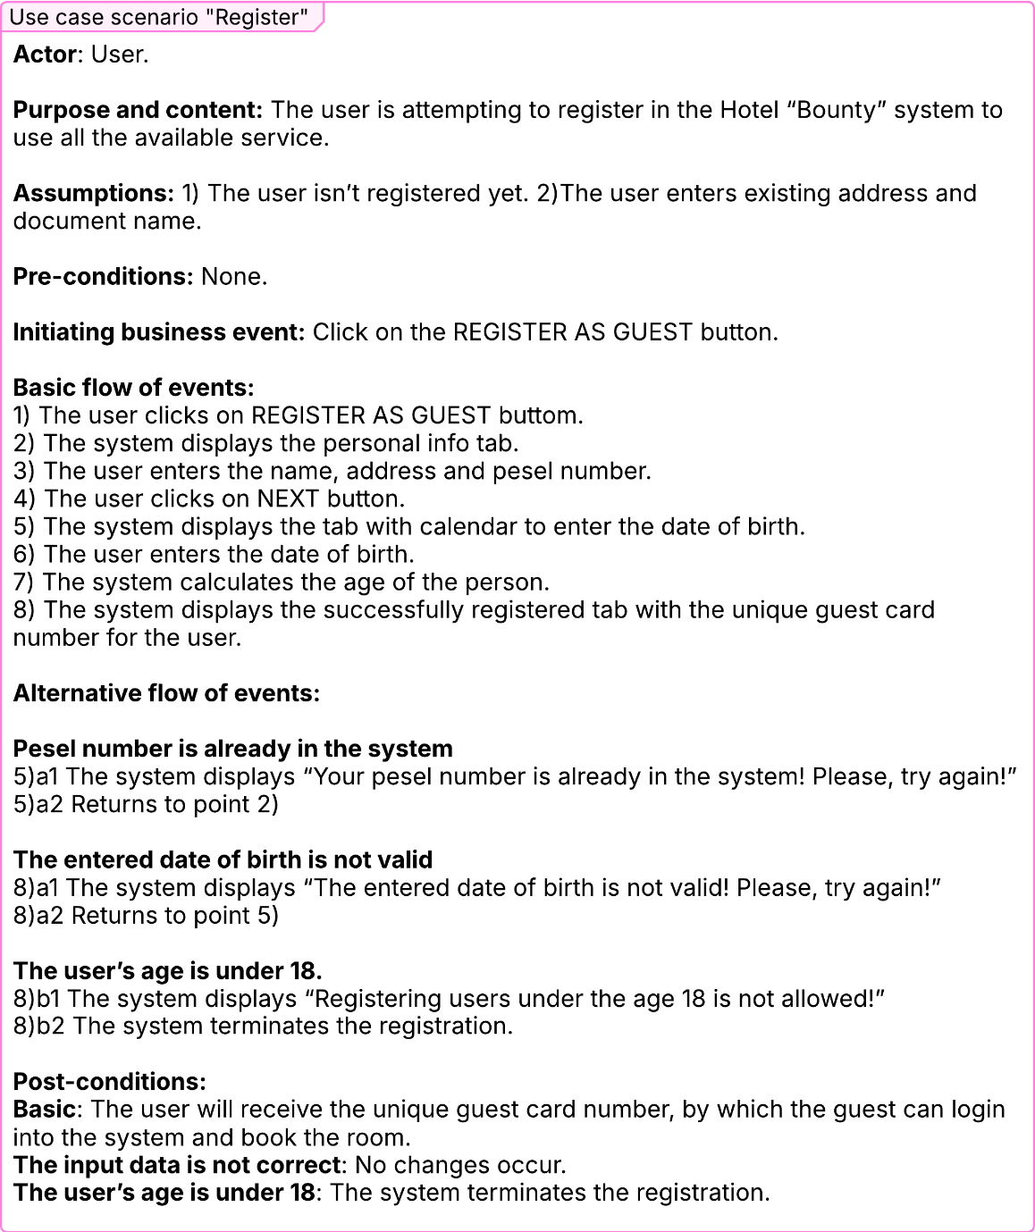

Activity Diagram “Register”
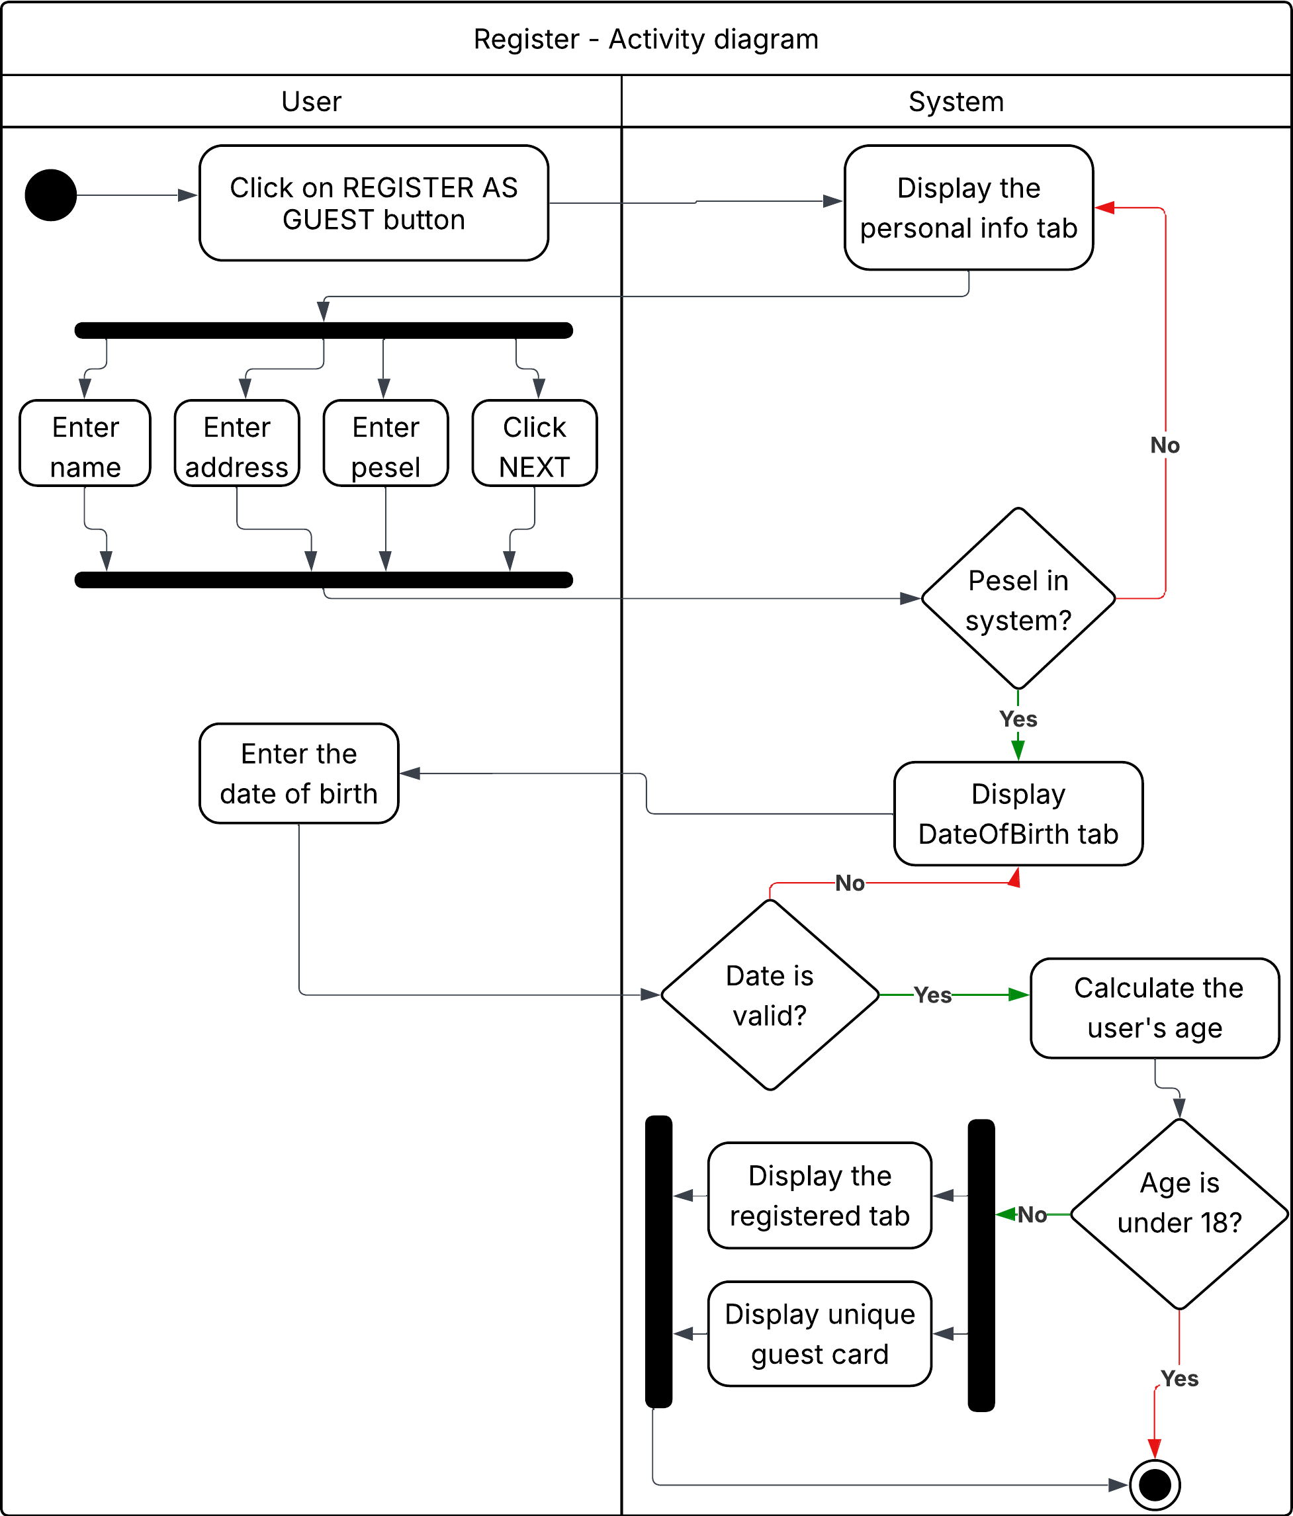

Activity Diagram Description “Register”
The activity diagram illustrates the process of a user registering as a guest in the system. The workflow starts with the user clicking on the REGISTER AS GUEST button. After that, the system displays the tab for registration, where user is supposed to enter name, address an pesel number. Upon confirmation of the entered data, the system automatically verifies whether the provided PESEL number already exists in the database. If the pesel number is already in the system, the system requests the user to enter the data again.

The next registration tab promotes the user to enter the date of birth via calendar. The system also checks if the date is valid. In cases where the date is invalid, the user is prompted to repeat the entry. Also, if the user’s age is under 18, the registration process is automatically terminated in accordance with the Hotel “Bounty” policy.

Finally, after successful registration the user will receive the unique guest card number, by which the guest can login into the system and book the room

Use case scenario “Pay for booking”
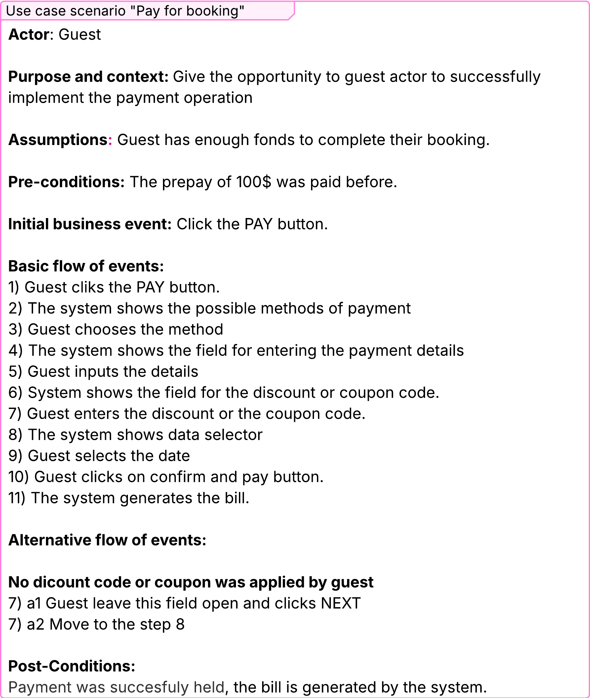

Activity Diagram “Pay for booking”
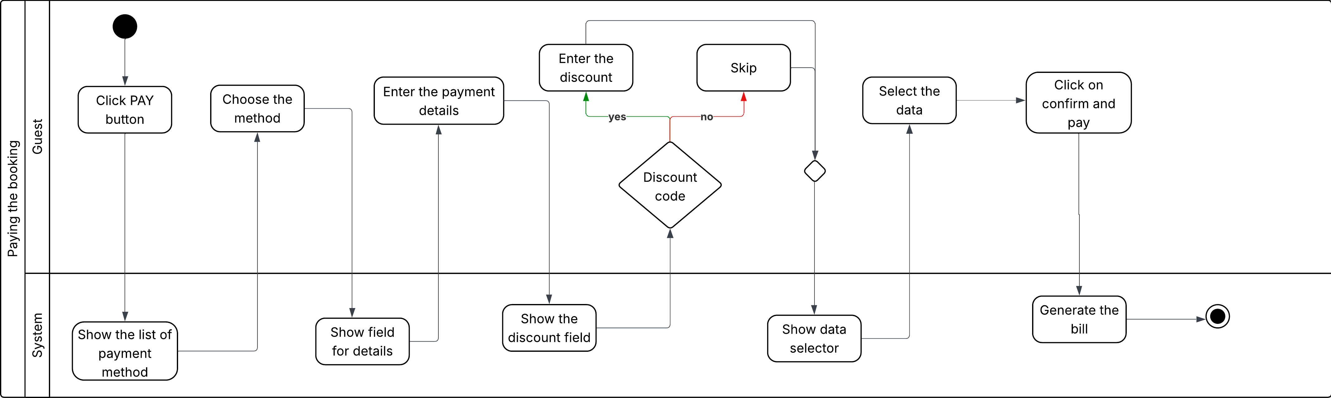

Activity Diagram Description “Pay for Booking”
The activity diagram illustrates the process of paying for a booking in the Hotel Bounty system. The workflow starts when the guest clicks the PAY button. The system displays the list of available payment methods, and the guest chooses one of them.

After selecting the method, the system shows the field for entering payment details, which the guest fills in. Then, the system displays the field for entering a discount or coupon code. The guest can either enter the code or skip this step.

Next, the system shows the data selector, and the guest selects the required data. After that, the guest clicks Confirm and Pay, and the system generates the bill, completing the payment process.

Use case scenario “Make Booking”
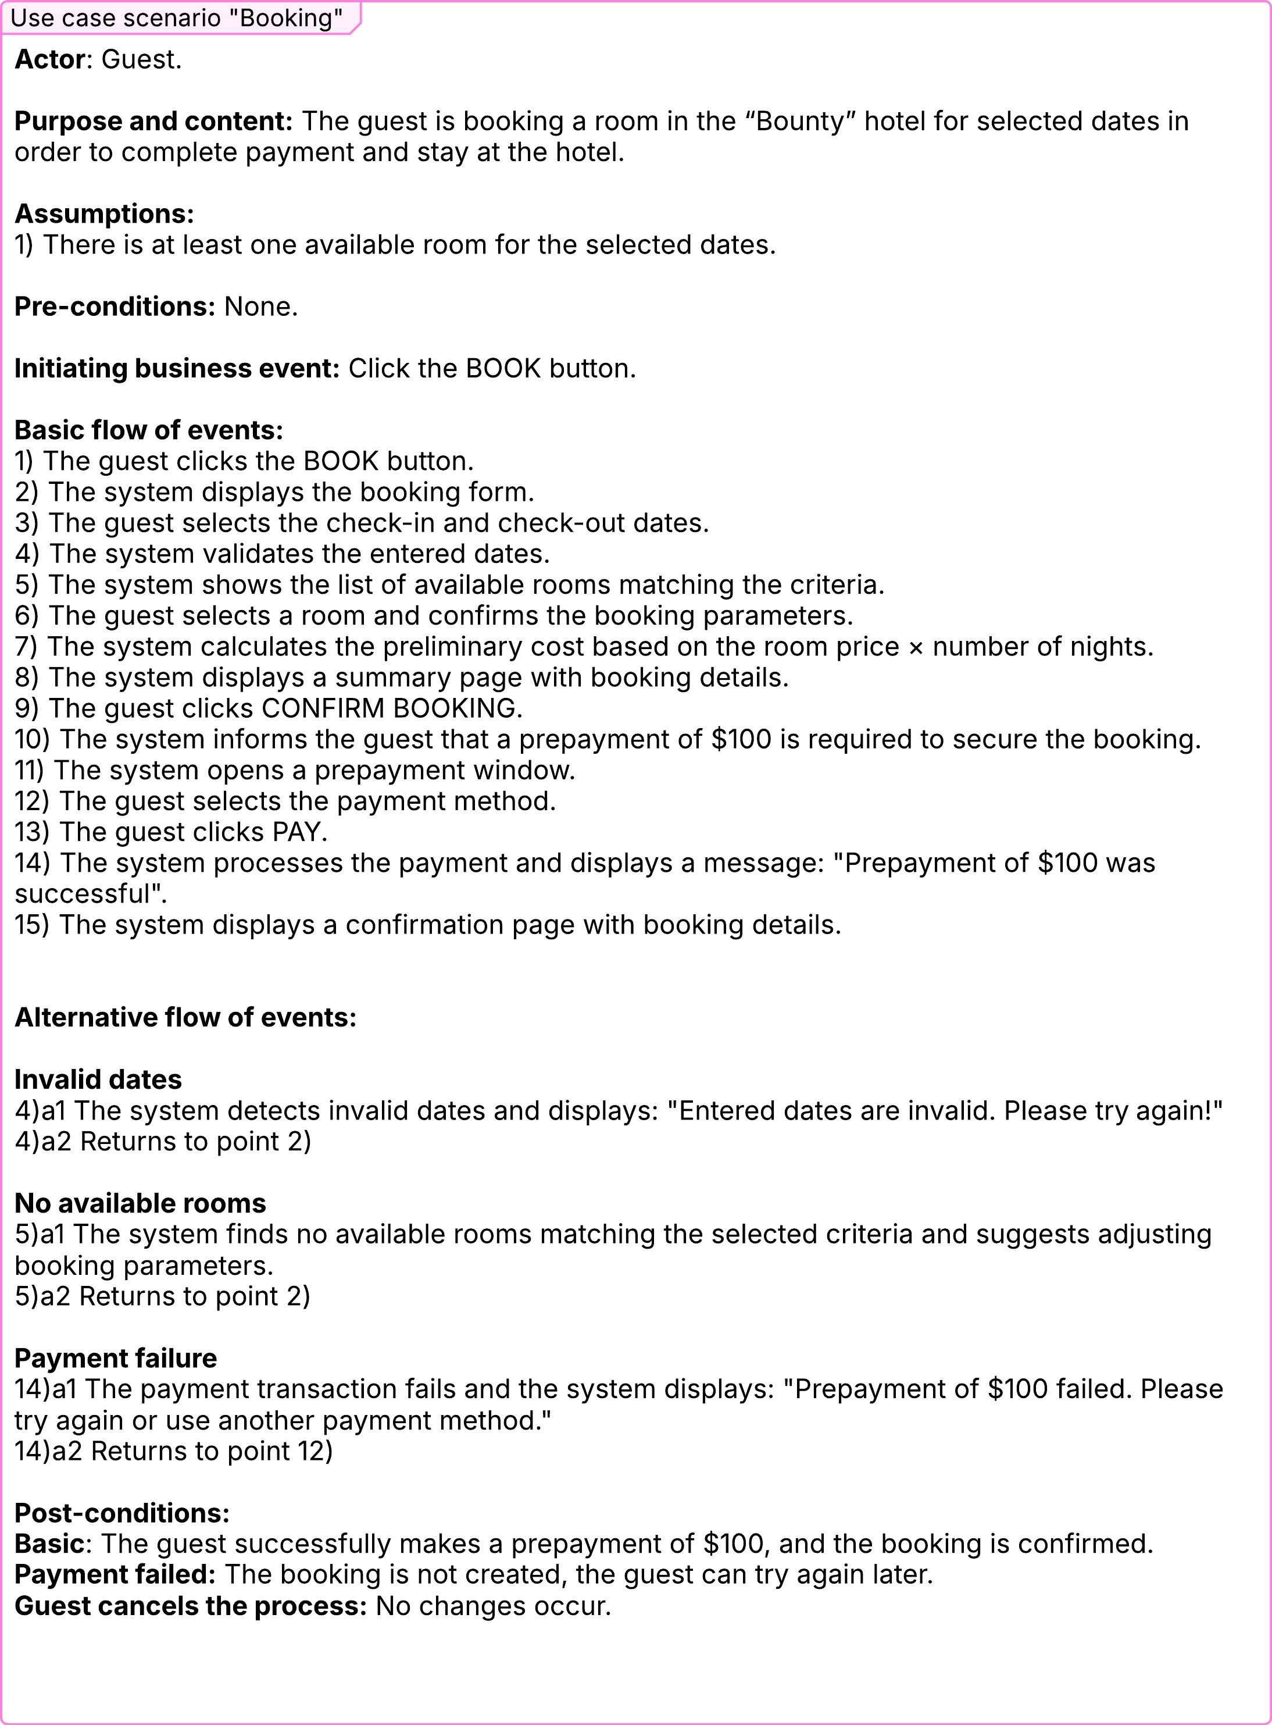

Activity Diagram “Make Booking”
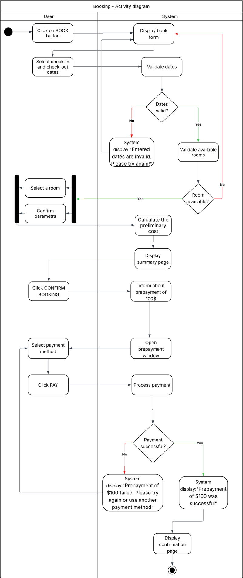

Activity Diagram Description “Make Booking”
The activity diagram illustrates the process of booking a room in the Hotel Bounty system. The workflow starts when the user clicks on the BOOK button. The system displays the booking form where the user selects the check-in and check-out dates. The system validates the entered dates. If the dates are invalid, the system displays a message and requests the user to try again.

If the dates are valid, the system checks room for availability. In case no rooms are available, the user is prompted to adjust the booking parameters. When a room is available, the user selects it, confirms the parameters, and the system calculates the preliminary cost and displays the summary page.

The user then clicks CONFIRM BOOKING, after which the system informs a required prepayment of $100 and opens the prepayment window. The user selects the payment method and clicks PAY. If the payment fails, the system displays an error message and allows the user to try again. If the payment is successful, the system confirms the booking and displays the confirmation page.

State Diagram Booking Class

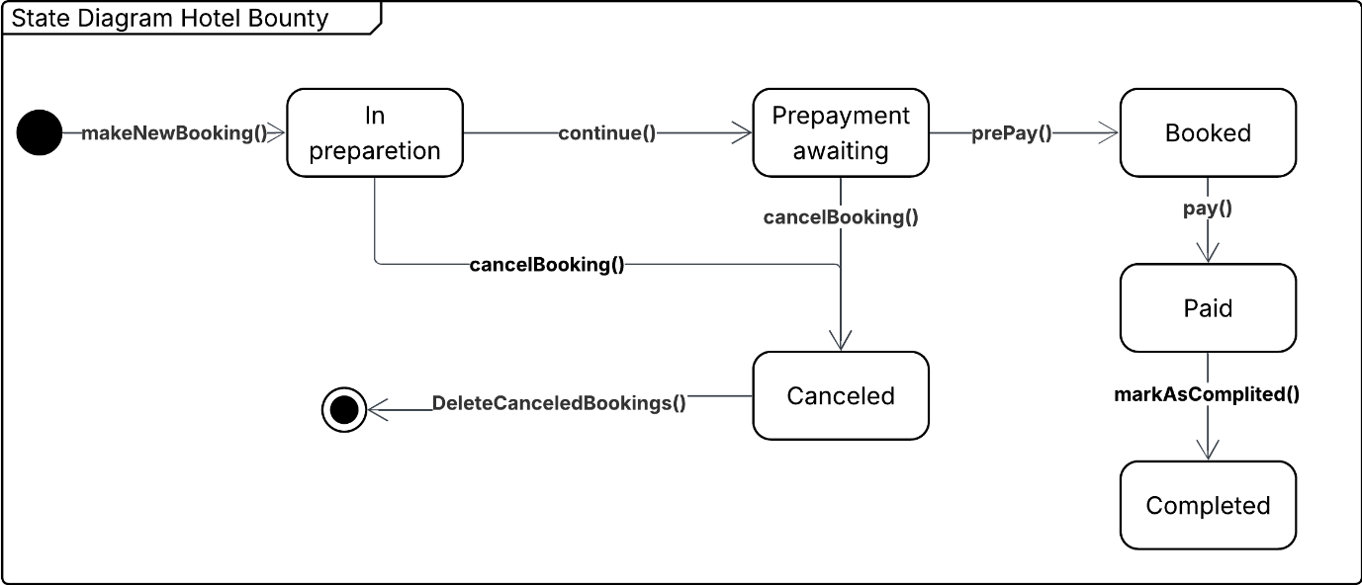

State Diagram Description
The state diagram illustrates the life cycle of a booking object in the Hotel Bounty system.
When the makeNewBooking() method is used, a new booking is created with the status “In preparation”.

At the “In preparation” stage, the booking can also be canceled manually using the cancelBooking() method, which changes its state to “Canceled”. Once in the “Canceled” state, if no further actions occur, the booking is automatically removed from the system after one hour.

Once the details are confirmed, the booking moves to the “Prepayment awaiting” state using the continue() method. The system then waits for the guest to make a prepayment. If the guest cancels the booking before prepayment, the cancelBooking() method changes its state to “Canceled”. Once in the “Canceled” state, if no further actions occur, the booking is automatically removed from the system after one hour.

If the prepayment is successful, the prePay() method transfers the booking to the “Booked” state. The guest can then make a full payment using the pay() method, which changes the status to “Paid”. When the stay or service is completed, the markAsCompleted() method is called, and the booking changes its status to “Completed”.

Dynamic analysis on „Make a Booking”, „Prepay booking”, „Pay for booking” and “Cancel booking”use cases and “Booking class” state diagram
Following the above-presented diagrams, a dynamic analysis was performed. The result of this analysis indicated a need for further expansion on the design class diagram to encompass newly identified requirements and behaviors of the system. All changes introduced can be seen in the below presented final design class diagram. Changes would be discussed for each class separately.
“Booking” class
- Added a tagged attribute Status : BookingStatus to represent the booking life-cycle (PREPARING, BOOKED, PREPAYMENT_AWAITING, PAID, CANCELED, COMPLETED).
- Introduced methods (MakeNewBooking, MarkAsPaid, CancelBooking etc.) to reflect valid state transitions from the dynamic analysis.
- GuestCardNumber added as a qualifier, since bookings must be grouped and accessed by the guest card number during cancellation and payment flows.
“Bill” class
- TotalPrice treated as a derived/calculated value through GenerateBill().

“PaymentOperation” class
- Added methods Prepay() and Pay() to enforce valid steps from the payment workflow.
- Added validation to prevent modification of PaymentMethod, Bill and Booking references after payment is executed.

“Guest” class
- Age validation (18+) added after analysing the booking flow where minor guests cannot make reservations.
- GuestCardNumber kept as the main identifier connecting guests and bookings.

“Room” class and subclasses
- Dynamic analysis of room selection identified the need for additional attributes in specialised room types (MiniBarFilling, Terrace, AnimalFeeders, AllergyFriendly, etc.).
“Employee” class
- Booking, payment, and hotel management procedures required employees to have specific roles and constraints:
- receptionists must have valid DatabaseKey;
- security guards require verified SecurityCode;
- cleaners require Specialization.

Changes to the Class diagram after dynamic analysis
